**MINOR PROJECT 2**

**SYNOPSIS**

**ON**

**Chest-X-Ray Analyzer**

**Submitted By**

|  |  |  |  |
| --- | --- | --- | --- |
| Amit Kumar | Abhishek Sharma | Aditya Agarwal | Himanshu Khanduri |
| 500069164 | 500067644 | 500069294 | 500067739 |
|  |  |  |  |

***Under the guidance of***

**Dr. Hitesh Kr. Sharma**

Assistant Professor

Department of Cybernetics  
University of Petroleum and Energy Studies

upes-new-logo

**Department of Cybernetics,**

**School of Computer Science**

**UNIVERSITY OF PETROLEUM AND ENERGY STUDIES**

**Dehradun-248007**

**Jan- 2021**

 **School of Computer Science**

**University of Petroleum & Energy Studies, Dehradun**

**Project Proposal Approval Form (2020-2021)**

II

**Minor**

**PROJECT TITLE:** Chest-X-Ray Analyzer

**Abstract:**

Advances in machine learning and artificial intelligence techniques promise to increase computer-assisted diagnostic tests quickly, accurately, and reliably. And such strategies are important exclusively in areas with heavy loads or resources. These regions often show an increase in infectious diseases and report high mortality. Our research in machine learning and artificial intelligence algorithms aims to improve diagnostic accuracy and reliability, with the aim of defining and behaving algorithms considering Chest-X-Ray analysis as an area of our interest.

**Table of Content:**

|  |  |
| --- | --- |
| **TOPICS** | **Page No.** |
| **INTRODUCTION** | **2** |
| **LITERATURE REVIEW** | **2** |
| **PROBLEM STATEMENT** | **5** |
| **OBJECTIVE** | **5** |
| **SYSTEM REQUIREMENTS** | **5** |
| **UML DIAGRAMS** | **5** |
| **SCHEDULE/PERT CHART** | **6** |
| **REFERENCES** | **7** |

**Introduction:**

Chest X-Rays analysis is an effective research tool for medical image analysis and computer-assisted radiology diagnostics. The main goal is to improve the quality and productivity of radiologists by providing a computerized diagnostic and diagnostic system. A number of studies have been conducted on the use of machine learning techniques to produce a high-quality X-ray image separation method. Some review papers also have been published discussing various aspects of medical imaging analysis and computer-assisted radiology diagnostics. But here we are trying to complete existing methods by pointing to methods of chest X-ray imaging in the use of machine learning techniques. Our review begins with basic information for medical image analysis, chest radiography, and machine learning.

Introduction to Machine Learning Image acquisition, image formation, image analysis, and image-based visualization are part of computer-based processing and medical imaging analysis. Medical image analysis has evolved into a variety of indicators including pattern recognition, image extraction, computer vision, and machine learning. Meanwhile, Computer-Aided Diagnosis (CAD) has been part of the development of medical imaging analysis to support automated diagnosis and differentiation of various diseases. Radiology is a branch of medical science that uses imaging and radiation technology to diagnose and treat diseases. In radiology, CAD has been promoted as providing a "second opinion" to assist in the study of the radiologists' picture of Chest X-Rays (CXRs) in detecting the presence of the disease. There are various types of conditions and diseases that can be diagnosed such as atelectasis, constipation, infiltration, pneumothorax, edema, emphysema, fibrosis, effusion, pneumonia, pleural stiffness, cardiomegaly, nodule mass, ne hernia. In addition, many respiratory infections are highly dependent on CXR. One of the most important tasks in developing CAD capacity is to detect and separate infections from CXRs automatically. These applications can help improve the quality and productivity of radiologists' work by increasing the accuracy and consistency of radiology diagnostics and reducing image study time.

**Literature Review:**

A systematic literature review was performed by searching the following healthcare databases: Medline (1949-present), Pubmed (1947-present), Cumulative Index to Nursing and Allied Health (CINAHL) (1937-Present), the Cochrane Library Database (1974-Present) Scopus (1823-Present) and Embase (1980-Present). The “Medical Subject Heading” (MeSH) was used to identify related keywords. The search strategy was developed using variations of the following keywords: radiographer, radiologic technologist/technician, x-ray, image, film, radiograph, chest, thorax and axial.

The lead author reviewed all abstracts and identified papers which met the inclusion criteria. The other authors independently screened these papers to ensure they met the inclusion criteria. All authors met to compare findings; any differences in reviewers’ judgments were resolved through discussions until consensus was reached. Data was extracted by the lead author using a predesigned form and this data was entered into the results tables.For the purpose of the review, the quality of the studies were assessed based on a variation of the questions provided in the Critical Appraisal Skills Programme Oxford UK (CASP) 7 tools for a diagnostic study. The combination was used as no suitable alternative was available for these mixed methods papers. If the answer to a question was ‘yes’ the article was scored 1, if the answer to a question was ‘can’t tell’ or ‘no’ a score of 0 was awarded for that question

A study conducted by Tape and Mushlin (1988) to study the effect of routine chest x-rays of pre-operative patients at risk for postoperative disease. Patient records from 341 admissions were reviewed to determine the relationship between chest x-ray results and postoperative chest complications. Patients who had major abnormalities had a 40% postoperative complication rate, compared with 9% for those with normal x-rays; but only 13% of the complications occurred in patients with major abnormalities. Nine patients had x-ray findings that led to clinical action: three with potentially beneficial management changes (congestive heart failure in 2, fibrosis in 1) and six with potentially detrimental clinical action (false diagnosis of tuberculosis in 2, false diagnosis of nodules in 2, falsely normal chest x-ray in 2). None of 50 surgical cancellations occurred as a result of an abnormal x-ray. All the beneficial effects attributable to preoperative chest x-rays accrued to patients who had clinical evidence of chest disease.

The authors conclude that routine chest x-rays were not helpful in improving patient outcomes. They recommend ordering preoperative chest x-rays based on clinical indications so that the likelihood of false positives and false negatives and their associated detrimental effects can be minimized.

**Problem statement:**

To develop a pathology localization framework and weakly supervised image classification as due to considering of large image capacity we adapt Deep Convolutional Neural Network (DCNN) architecture for weakly-supervised object localization.

**Objectives:**

* X-ray images and computer-aided diagnosis can be used as a massive, faster and cost-effective way of screening.
* To bring down the time for testing drastically.
* To make a clinically effective prediction, training with more massive datasets and testing in the field will be immensely useful.

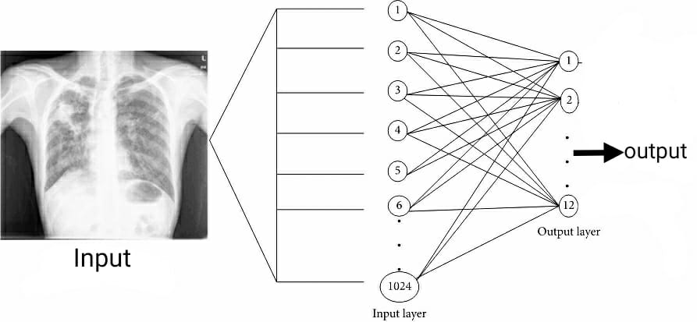

**System Requirements: (Software/Hardware)**

* While some less computationally intensive ML applications can be run on central processing units (CPUs), most currently applied ML algorithms require hardware with dedicated graphics processing units (GPUs).
* Experts involved in ML development should make use of online resources for creating, sharing, and discussing ML algorithms.

**Hardware**

* 100 GB external hard disk
* NVIDIA GTX 1070 GPU 8 GB
* 4 GB of RAM

**Software**

* Windows(7 and above)
* Python versions(2.6.X , 3.6.X)
* Jupyter Notebook
* Anaconda
* Tensorflow
* Matplotlib
* Keras
* GitHub

**UML Diagrams**

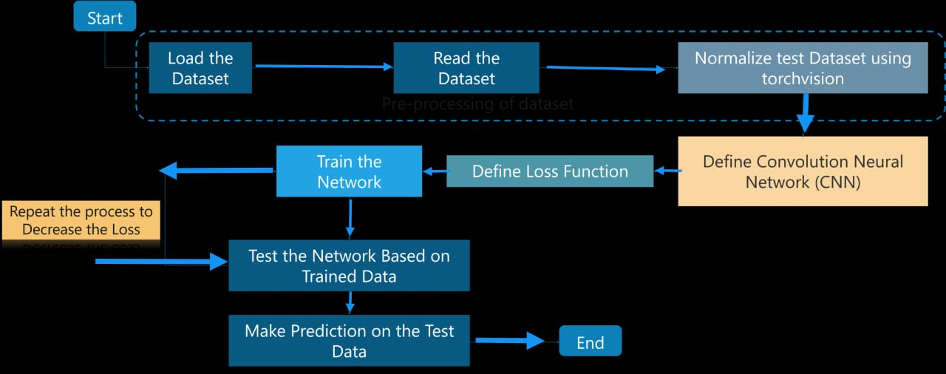

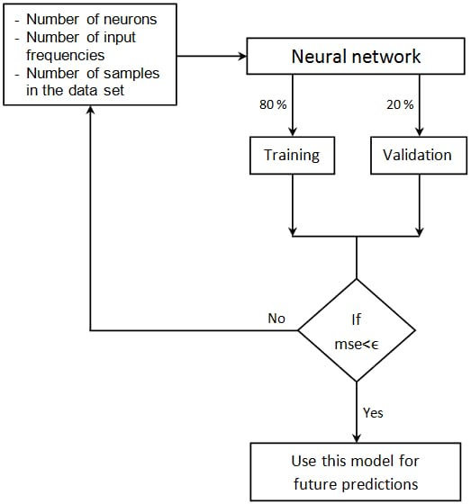

**Schedule: (PERT Chart)**

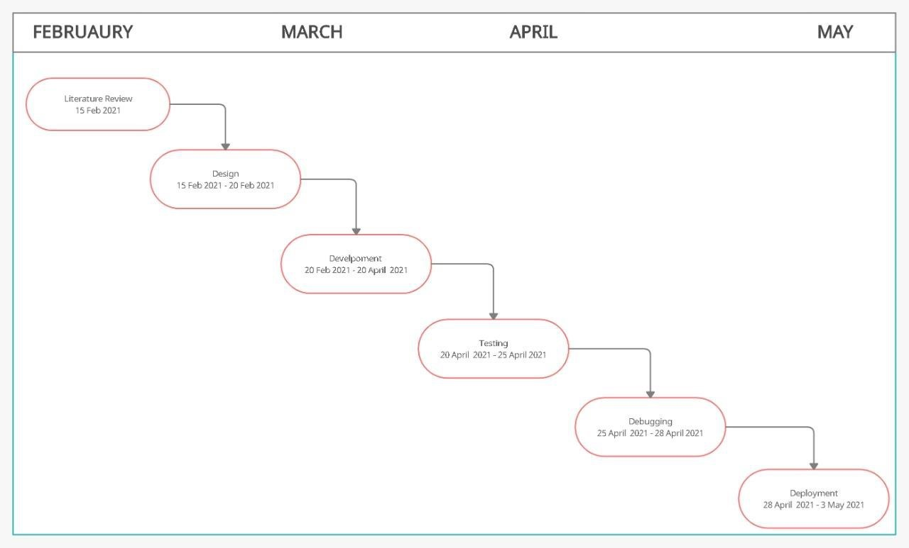

**References:**

1. Zha N, Patlas MN DR. Radiologist burnout is not just isolated to the United States: perspectives from Canada. J Am Coll Radiol. 2019;16(1):121-123.
2. Kane L. Medscape National Physician Burnout, Depression & Suicide Report 2019. medscape com/slideshow/2019-lifestyle-burnout-depression-6011056. Published online 2019.
3. Lee CS, Nagy PG, Weaver SJ, Newman-Toker DE. Cognitive and system factors contributing to diagnostic errors in radiology. Am J Roentgenol. 2013;201(3):611-617. doi:10.2214/AJR.12.10375
4. Delrue L, Gosselin R, Ilsen B, Landeghem A, De Mey J, duyck philippe. Difficulties in the Interpretation of Chest Radiography. In: Comparative Interpretation of CT and Standard Radiography of the Chest. ; 2011:27-49. doi:10.1007/978-3-540-79942-9_2
5. Wang X, Peng Y, Lu L, Lu Z, Bagheri M SR. Chestx-ray8: Hospital-scale chest x-ray database and benchmarks on weakly-supervised classification and localization of common thorax diseases. In: Proceedings of the IEEE Conference on Computer Vision and Pattern Recognition. ; 2017:2097-2106.
6. et al. Johnson AEW, Pollard TJ, Berkowitz S. MIMIC-CXR: A large publicly available database of labeled chest radiographs. arXiv Prepr arXiv190107042. Published online 2019.
7. et al. Irvin J, Rajpurkar P, Ko M. Chexpert: A large chest radiograph dataset with uncertainty labels and expert comparison. In: Proceedings of the AAAI Conference on Artificial Intelligence. ; 2019:590-597.
8. Taylor AG, Mielke C MJ. Automated detection of moderate and large pneumothorax on frontal chest X-rays using deep convolutional neural networks: A retrospective study. PLoS Med. 2018;15(11).
9. Rajpurkar P, Irvin J, Zhu K et al. Chexnet: Radiologist-level pneumonia detection on chest x-rays with deep learning. arXiv Prepr arXiv171105225.
10. Pan I, Cadrin-Chênevert A CP. Tackling the Radiological Society of North America Pneumonia Detection Challenge. Am J Roentgenol. 2019;213(3):568-574.

**Approved By**

**Dr. Hitesh Kumar Sharma Dr. Monit Kapoor**

**(Name & Sign) (Name & Sign)**

**Project Guide Head of Department**